CHAPTER 6: The Earth in space
Worksheet 6.2

Surf’s up
Science Quest 7: pages 221–222
Student: Class:
Sam, Heidi and Jake surfed four days in December. They travelled down the Victorian west coast to surf at Point Danger just outside Portland. They copied the tide times so they could plan their surfing trip to make sure they surfed at high tide each day. They didn’t want to get up too early and surf before sunrise. They also never bothered surfing when it was too close to low tide.
Sam, Heidi and Jake drew up a plan for each of the four days.
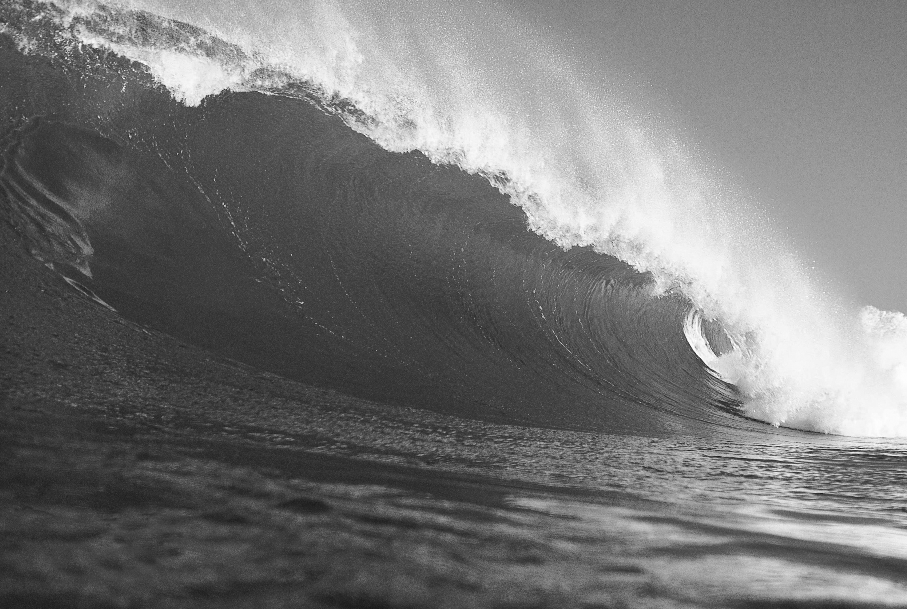
1. On the table below, circle the times when you think they would surf.

Tide times for Portland
4 December 2010  New moon |  | 11 December 2010 First quarter moon |  | 19 December 2010  Full moon |  | 27 December 2010  Last quarter moon
24-hour time | Height in metres | 24-hour time | Height in metres | 24-hour time | Height in metres | 24-hour time | Height in metres
0025 | 1.01 | 0345 | 0.84 | 0035 | 1.00 | 0407 | 0.76
0820 | 0.39 | 1031 | 0.43 | 0814 | 0.37 | 1124 | 0.38
1025 | 0.42 | 1424 | 0.50 | 1111 | 0.43 | 1552 | 0.45
1653 | 0.06 | 2030 | 0.25 | 1714 | 0.11 | 2043 | 0.36

CHAPTER 6: The Earth in space PAGE 2
Worksheet 6.2

Heidi played around with the figures in the table and found out that the tidal range was different for each day. She calculated the difference between the highest tide and the lowest tide for each day.

2. See if you can calculate and record what she found out.
Date | 4 December | 11 December | 19 December | 27 December
Moon phase
Tidal range

Sam noticed it was a different phase of the moon each time they went surfing. He knew that the moon had something to do with the tides from what he learned at school. He drew some sketches to remind himself why the tidal range changed. Jake chipped in and told Sam that spring tides start when there is a new moon or a full moon and that neap tides start when there is a first or last quarter moon.
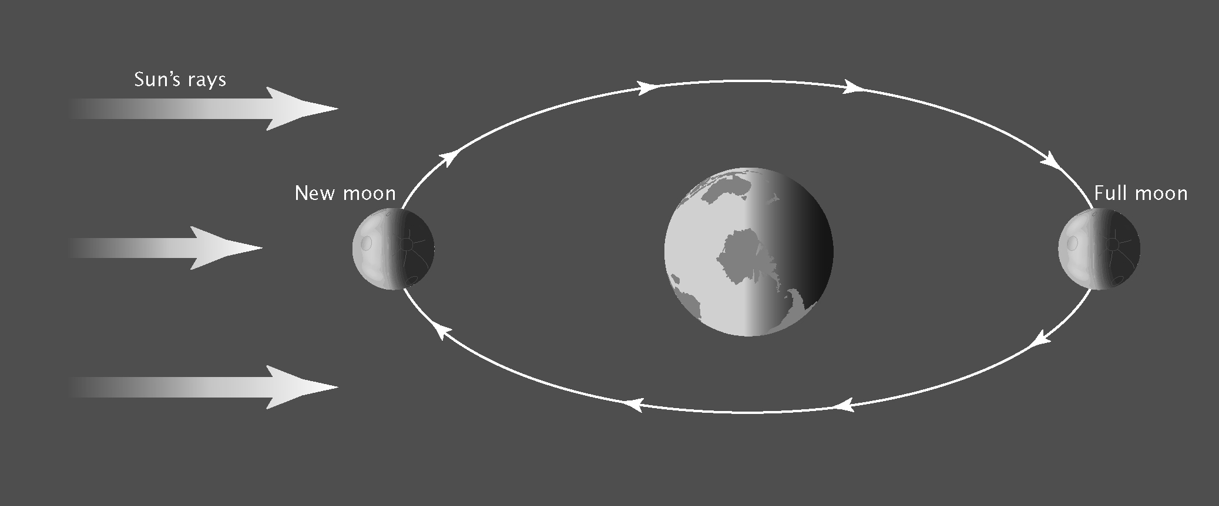
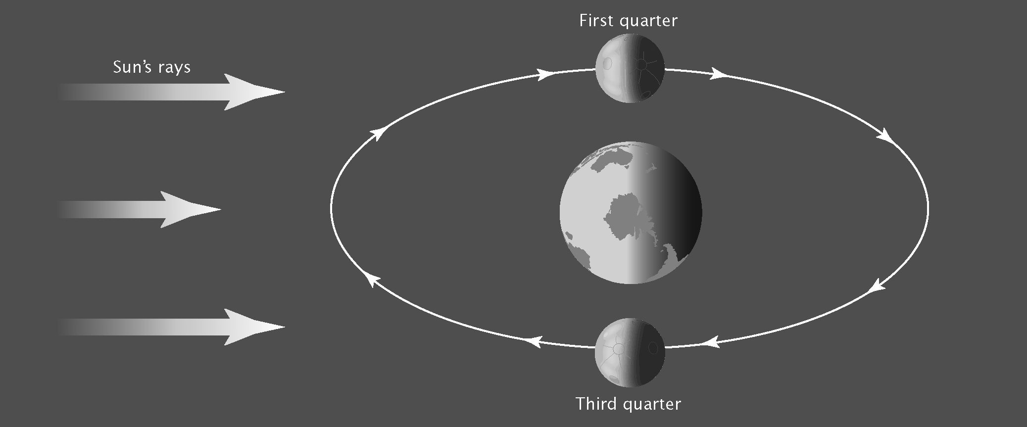
3. See if you can add dates to the sketches and label the type of tide in each diagram.

